Member of the Month – February 2020
Candelaria Martin Arndt, MD

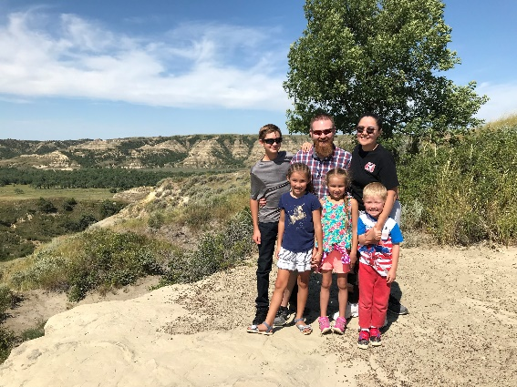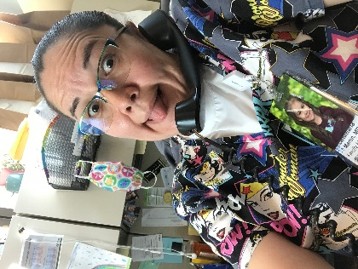
Undergraduate School: University of New Mexico
Medical School: University of North Dakota School of Medicine and Health Sciences
Residency: University of North Dakota Family Medicine Residency in Minot
Any additional training: Altru Family Medicine Residency Obstetrical Fellowship
Current Position/Practice Location: Altru Lake Region, in Devils Lake, ND
Family: Married with 4 children

Family Medicine Questions:
- Who is someone along your path that inspired you and why?
  - Dr. Heidi Bittner. In my third year of medical school I was fortunate enough to participate in the Rural Opportunities in Medical Education (ROME), and spend 7 months in Devils Lake working with the physicians here. Dr. Bittner took the time and effort to introduce me to life outside the clinic. She showed me the joy of knowing your patients and their role in the community and how in a small town the community and medical providers support each other. Her work life balance was inspiring, and I could see myself one day being like her.
- If you weren’t a physician, what do you think you would be doing?
  - No, idea. I would like to think I would be working for the Travel Channel and exploring the world while getting paid for it. My father tells me all I ever said I wanted to be is a doctor, never did I suggest other occupations. On my mother’s side I come from a long line of traditional Navajo medicine men and women. We believe the path of being a healer is chosen for you, and not something you choose for yourself.
- What is the best part of your current position/practice?
  - My partners. The support we give each other is amazing. In a small practice group, you really need to have a strong team. It is easy to collaborate on cases and even get things covered in times of crisis. Earlier this year three of the five of us were out on family medical leave and Covid quarantine, the remaining two picked up the slack and never complained about payback for the extra call coverage, and they know the favor will be returned without having to ask. We care about one another’s well being professionally and personally.
Fun Questions:
- Where’s your favorite place in the world?
  - In the mountains.
- What are you currently binge watching?
  - Cobra Kai. Didn’t think I would like it, but I find myself cheering on the characters and even shaking my head at the bad decisions.
  - How many states have you visited? 22

