Jacinta Thompson Klindworth, MD FAAFP

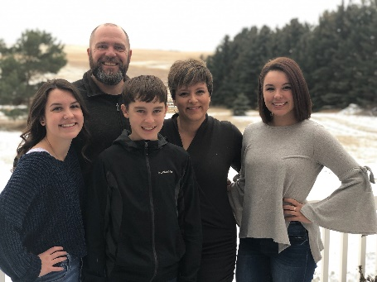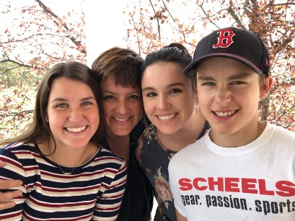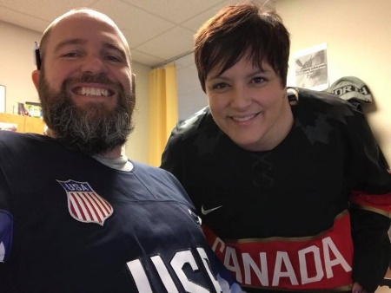

Undergraduate school:
University of Jamestown, formerly known as Jamestown College.
Jamestown, ND

Medical School:
University of Alberta Faculty of Medicine and Dentistry.
Edmonton, Alberta Canada

Residency:
University of North Dakota, CFM Bismarck Bismarck, ND

Current Position/Practice Location:
Staff Physician at Coal Country Community Health Center Beulah, ND Chief of Staff, Sakakawea Medical Center Hazen, ND

Family: Husband Eric. 3 children Emma (age 21), Camille (17), Ronan (13).

Family Medicine Questions:

Who is someone along your path that inspired you and why?
My personal family doc Sandra Kavanaugh, MD. She took care of me when I was a medical student and during my first pregnancy. As a medical student, I was panicked that a pregnancy and time off afterward would affect my training. She reassured me that I had my whole life to be a doctor and that everything would be just fine. She was, of course, absolutely right.

If you weren’t a physician, what do you think you would be doing?
Honestly, I am not sure. I never really had a plan B. I considered becoming a paramedic, but likely would have continued down a research path.

What advice would you give to a young physician starting out?
Get involved in your community and your state academy! And when you feel settled in, teach!

Fun Questions:
The last book you read? The Handmaid’s Tale
What are you currently binge watching? Downton Abbey
How many states have you visited? 34 (not too bad for a girl from Canada).

